“We Are The Fools Who Say Things” is a new band from Port Washington Ny. We play mainly classic rock, but we also are influenced by all styles. We all met playing music together around Port and the surrounding areas.

Aden Neuwirth is a composer & student at Berklee College of Music studying contemporary writing and production. He has been in bands for 10 years and grew up in Port Washington. He is planning to study Contemporary Writing and Media Production

Jake is a Berklee College of Music graduate and Port Washington native. He teaches piano and voice throughout Long Island and Queens. It is an absolutely privilege for him to play with such talent in Port Washington.

Jonathan Goldberg is a 2nd year student at Berklee College of Music studying professional music with concentrations performance, music education and instrument repair. He is a Schreiber High School graduate and a teacher at Bach to Rock Music School. He has been the guitarist in several bands and pit orchestras around the New York and Boston areas.

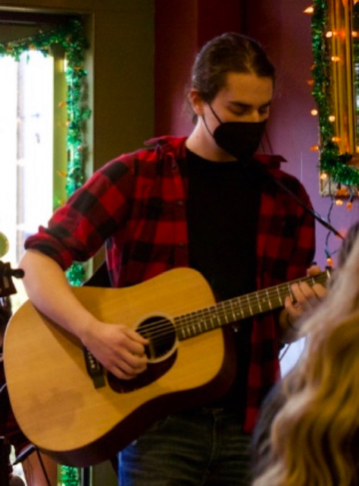

Hi I’m Kieran Fink. I’ve been in bands for about 10 years and am a high school graduate. I’m excited to be performing and majoring in musical theatre at Marymount Manhattan

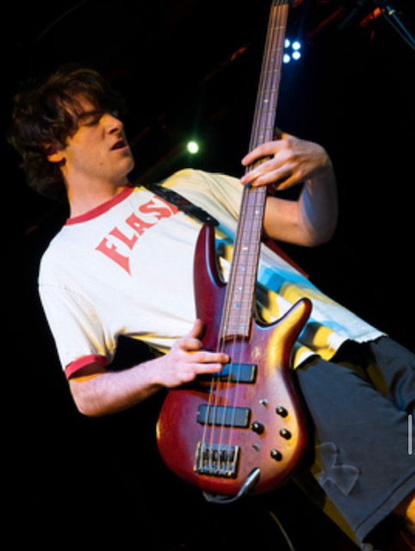

Noah Corsitto just graduated Schreiber High School. He recently played Burt in Mary Poppins at the “Port Summer show” and has been in many musicals around the Port Washington area.